Written and Performed by
Leslie McCurdy
www.lesliemccurdy.ca

“Unquestionably one of the best performances I have ever attended!!”
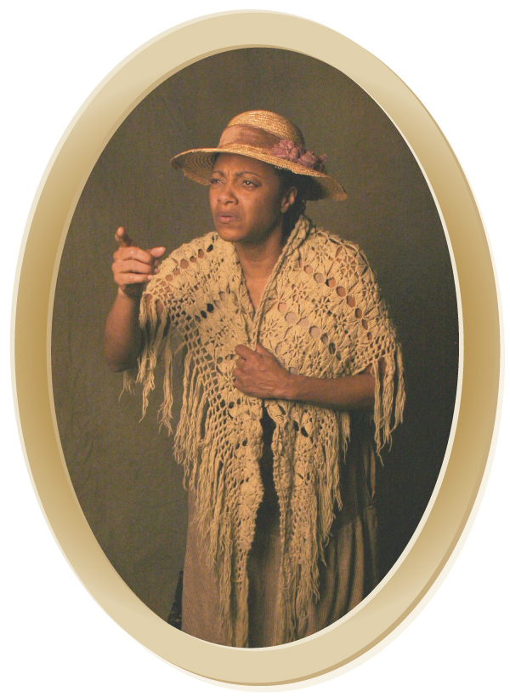
The Spirit of Harriet Tubman
Written and Performed by: Leslie McCurdy

Born into slavery in Maryland, Harriet Tubman not only escaped slavery alone, she returned to the south nineteen times to lead over three hundred other slaves to freedom in the northern United States and Canada. Her work as a nurse and a spy during the civil war was instrumental in helping the North defeat the South, thus forcing the abolition of slavery in the United States. Her entire life was spent working for the benefit of others, while asking little for herself. Now THE SPIRIT OF HARRIET TUBMAN continues that legacy. Unable to rest as long as there are those who need guidance, THE SPIRIT OF HARRIET TUBMAN, returns time and again to tell her story and share the things she learned along the way. On a minimally lit, barren stage with a trunk of costumes, THE SPIRIT OF HARRIET TUBMAN tells stories beginning with being hired out at the age of six and going through her solo flight from slavery, her involvement with the Underground Railroad, her victorious rescue missions in the civil war, and her continued commitment to others in her later years. These stories are told in Harriet Tubman's own words where available. This compelling one woman "docudrama" is valuable for is copious historical content as well as its artistic delivery!

Call Leslie at 519-256-8564 or 818-404-9176
email: ll.mccurdy@sympatico.ca or see her website at
www.lesliemccurdy.ca for more information

What People are saying about
THE SPIRIT OF HARRIET TUBMAN
A Finalist for a 1999 National Canadian Chalmers Award for ‘Best New Play for Young Audiences’

...”It was my great pleasure to present Leslie McCurdy ...the audience response to Ms. McCurdy’s performance in “The Spirit of Harriet Tubman” was overwhelmingly positive...(she) is an artist of exceptional skill and grace who has my highest recommendation.
Kate Newby, Artistic Director,
Calgary International Children’s Festival

“I witnessed a performance that was beyond belief, completely mesmerizing, and almost indescribable in terms of the emotions it brought out in me…Ms. McCurdy’s performance is one of the most amazing, compelling and thoughtful that I have ever had the good fortune of witnessing…something to be experienced by everyone…one will walk away changed forever!”
Elizabeth A. Fellows, Birmingham Mi.

“I consider myself very lucky to have been an usher to see “The Spirit of Harriet Tubman”. It was fantastic, an amazing performance, great writing, and a super story with an inspiring message. I was expecting it to be educational but instead it blew me away. It was also moving and beautiful to watch...it brought tears to my eyes.
Barbara Bryce, Guelph Ontario

“We’ve seen a lot of plays about Harriet Tubman across the country, and this is the one we like.”
Anita Peeks, Rosa and Raymond Parks Institute, Detroit, Mi.

“…what a wonderfully conceived and brilliant show you have in your talented hands…a deeply gifted actress…I was bowled over by the experience!”
Artistic Director, Smile Theatre
Toronto Ontario, Canada

“Your acting was amazing. I think this was an amazing experience for me and I feel so privileged to have been able to see it.
Christina Swanson, Grade Six Student

“Oprah should know about this!”
Tour Guide, Baltimore Maryland

Recent Tour Highlights

National Storytellers Conference, St Catharine’s Ontario Canada–Harriet Tubman’s Church!

October 2007–Public and School Performances, Northern Interior, British Columbia, Canada

Rialto Square Theatre, Joliet Illinois, (Returning February 2010)

North Shore Performing Arts Centre, Skokie Illinois (Returning February 2010)

Brock University, St. Catharine’s Ontario, Canada (Third Appearance!)

The Persephone Theatre, Saskatoon Saskatchewan, Canada

MASC (Multicultural Artists for Schools and Communities) Tour, Ottawa Ontario, Canada

Calgary International Children’s Festival, Calgary Alberta, Canada

St. Albert’s International Children’s Festival, St. Albert Alberta, Canada

Winnipeg International Children’s Festival, Winnipeg Manitoba

Reg Lenna Civic Center, Jamestown New York

Jarson Kaplan Theater, Arnoff Center, Cincinnati Ohio

Performances in Schools across Ontario, Michigan, Chicago Suburbs, Los Angeles

Over 200 performances Annually!!

THE SPIRIT OF HARRIET TUBMAN

February 23, 2006 - performance date Publish date:
February 24, 2006

by S. James Wegg
History lesson should be learned year round

Leslie McCurdy as Harriet Tubman-Davis is a match made in heaven. From her opening shaky-hand entrance declaiming “Help is still needed – that’s why I came back,” to her husky mezzo rewrite of “Mine eyes have seen the glory” (“Uncle Sam is rich enough to give you all a farm”) the spirit of her hero is much in evidence.

Not surprisingly, the school performances in Niagara were quickly sold out—this kind of living history beats teachers and textbooks any day. But, inadvertently, that success, led to the only fly in the ointment: the script dwells too much on the historical at the expense of the emotional. Consequently, the onlooker’s feelings more often hover around annoyance rather than outrage at North America’s shameful (but good for commerce!) treatment of slaves.

McCurdy does best at the opposite ends of the age spectrum. The young “Minty” bursts with energy and wide-eyed enthusiasm as she recalls taking care of a baby—when only seven herself—and the dangerous consequences of helping herself to a cube of sugar from a white woman’s table.

As the indefatigable octogenarian, her passion for justice and unstoppable need to help others effectively throws down the gauntlet to the comparatively spoiled audience as they shift self-consciously in their plush seats. Lines like “We was safe from the laws of the U.S.” got nervous chuckles, where the berry in the milk pail gag reaped “er, we’re-laughing-with-you” guffaws.

As the courageous Underground Railroad conductor, the avalanche of facts and scenes slipped by so quickly that it was hard to truly gauge just how it felt to return for her husband, only to find that the already free man had no interest in following his wife and had already moved on to another partner. More might have been made of the huge irony that once safely free in Canada, Tubman realized she’d never been so alone. That sense of community played into the hands of many a “Massa,” who rationalized their subhuman values by warehousing at least the healthy and docile under the same squalid roof.

Absent too was the actual moment of liberation. How must it have felt to reach the free North? What was the first conversation with a Canadian like? What kind of silent racism was practiced in St. Catharines?

But let’s be clear – these seeming criticisms are in fact high praise. With the production confined by time (more than an hour couldn’t work with school boards), the desire to know the rest of the story (especially the intriguing possibility that Tubman’s favourite niece might have been a daughter) is a great compliment to the sincerity and artistic skills that McCurdy brings to every line. Screenwriters take note: here’s a story with legs and a talented advocate to bring it home. JWR

Your comments are always welcome at JWR. Click below to have your say. If selected for publication, you could win a copy of JWR: The First Lustrum (2001–2006). Next draw: December 31, 2009

Feedback to JWR

Featured performer - Leslie McCurdy

Further information, future screening/performance/exhibition dates, purchase information:
Centre for the Arts - Brock University

Cross-reference (click on the poster for related work):

Copyright © 2001-2009 James Wegg & Associates/JWR
The content of this page is the sole responsibility of JWR and does not necessarily reflect the views or opinions of its advertisers and sponsors. All images are in the public domain or used with permission. Please contact the Managing Editor (jamesweggreview@bellnet.ca) with any concerns.
Where will you travel today?



